**Create Example of Range partitioning**

To perform administration tasks on range partitioning table one table emp_present with three partitions was created. Several rows containing sample data were inserted in the table. The result of command running is presented below.

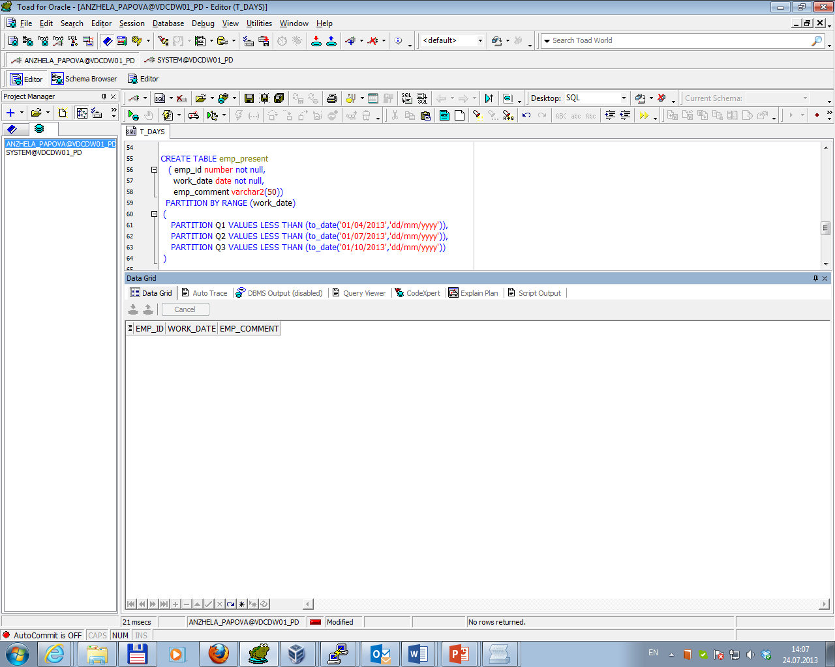

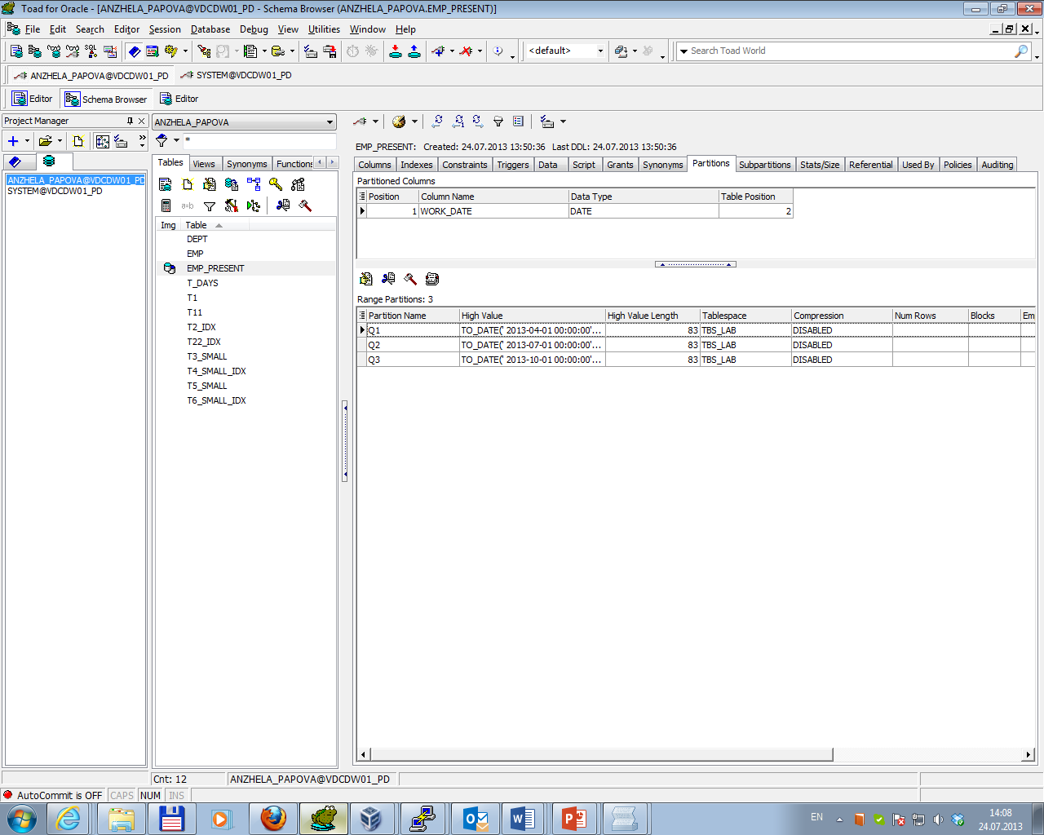

Adding Partitions

Command ALTER TABLE ... ADD PARTITION allows to manually add new partitions to a partitioned table to the "high" end (the point after the last existing partition). The result of command running is presented below.

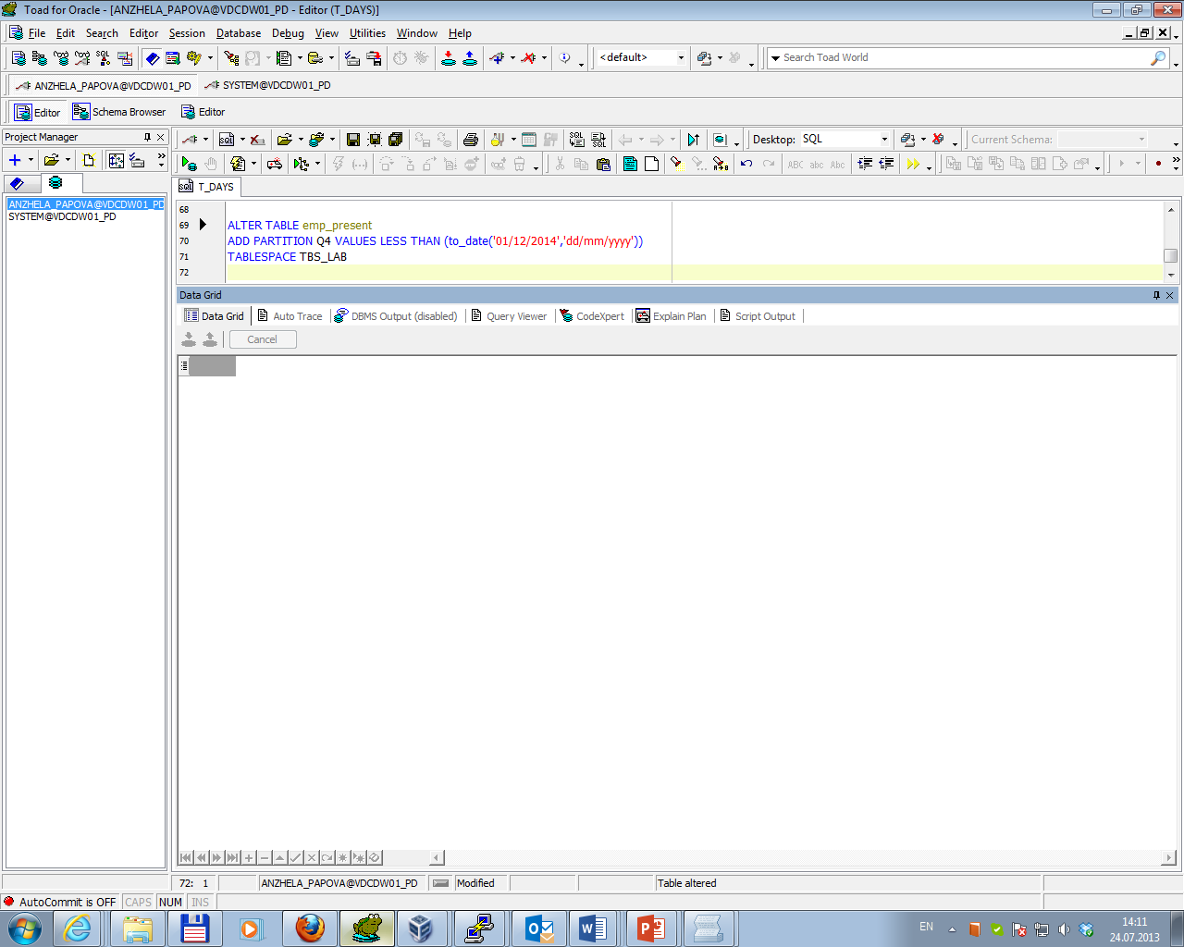

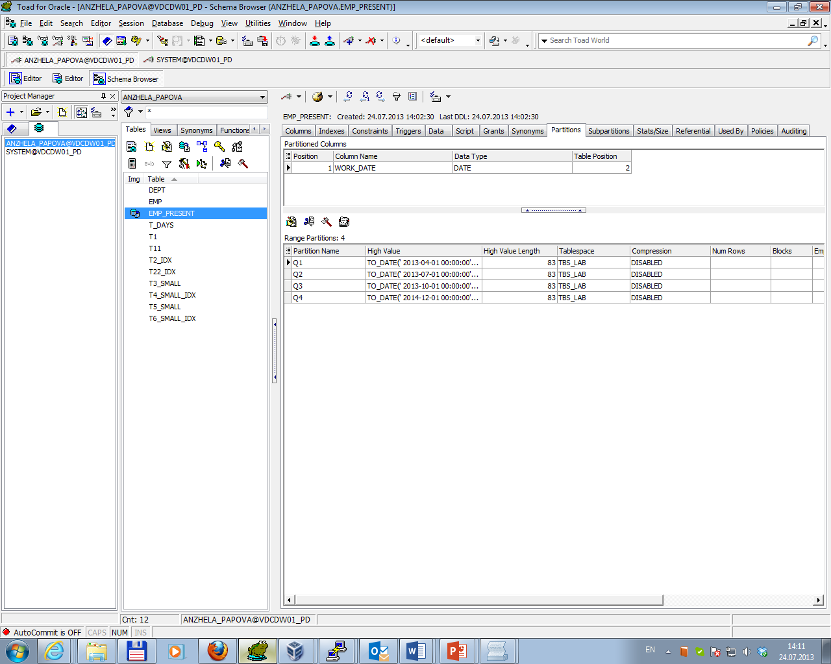

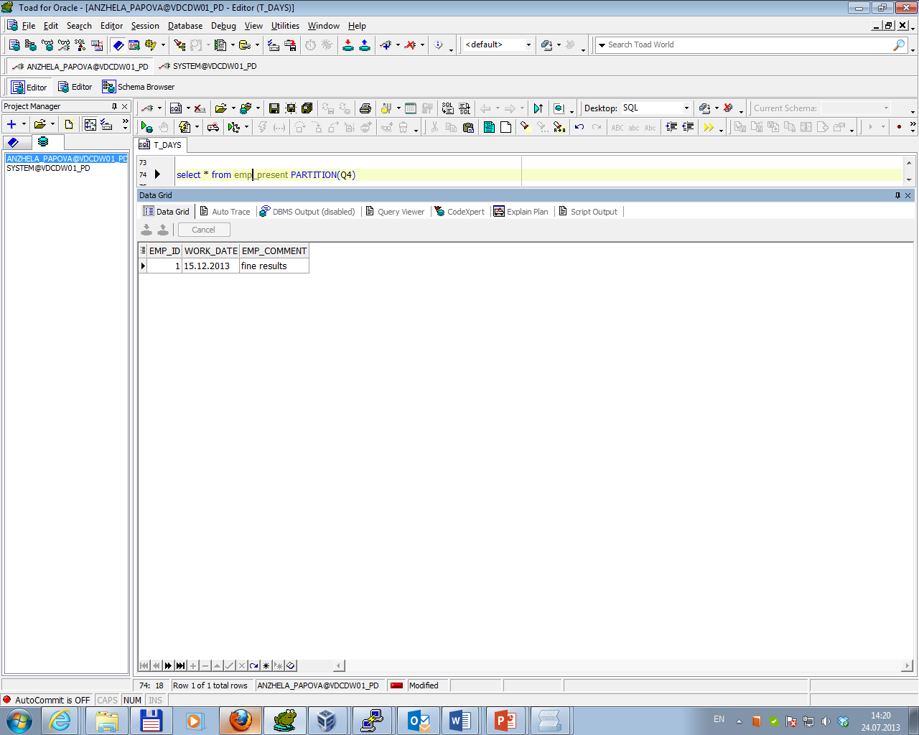

Dropping Partitions

Command ALTER TABLE ... DROP PARTITION allows to drop a table partition (with the data in the partition). The result of command running is presented below.

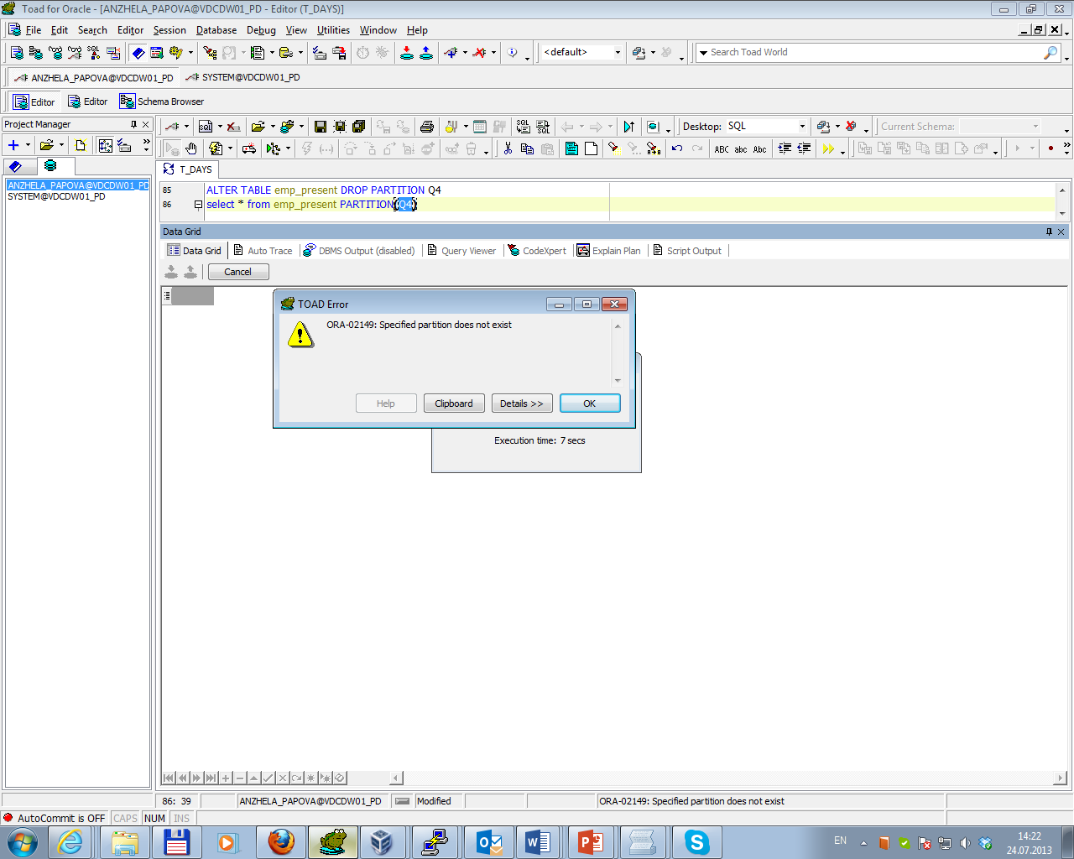

Merging Partitions

Command ALTER TABLE ... MERGE PARTITION allows to merge the contents of two partitions into one partition. The two original partitions are dropped. The result of command running is presented below.

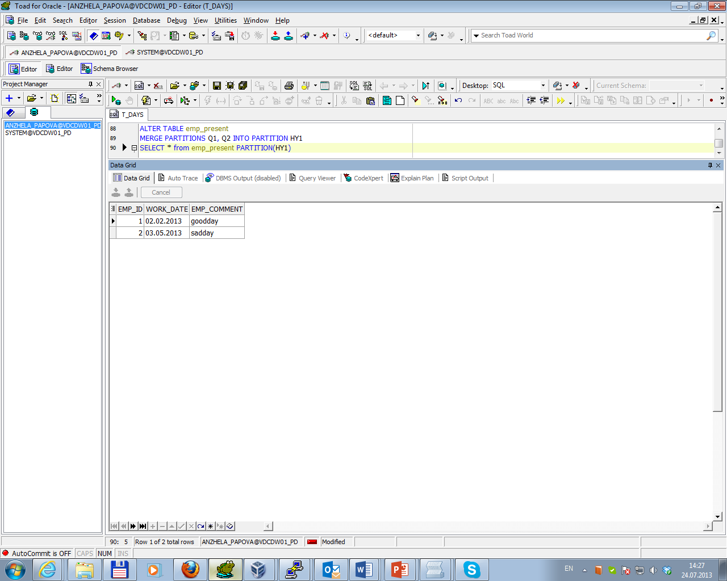

Moving Partitions

Command ALTER TABLE ... MOVE PARTITION allows to:

* re-cluster data and reduce fragmentation;
* move a partition to another tablespace;
* modify create-time attributes;
* store the data in compressed format using table compression.

The result of moving partition to another tablespace is presented below.

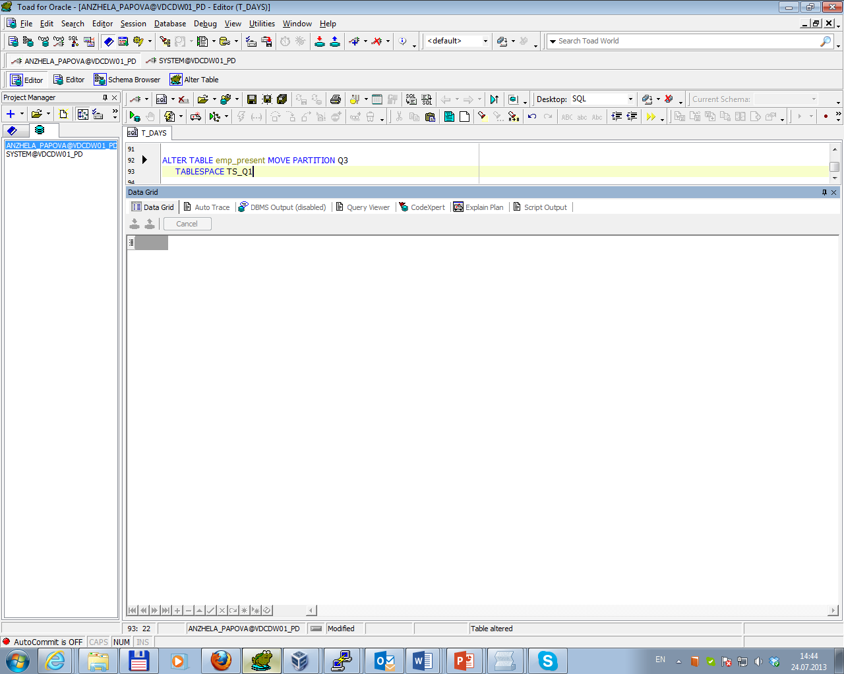

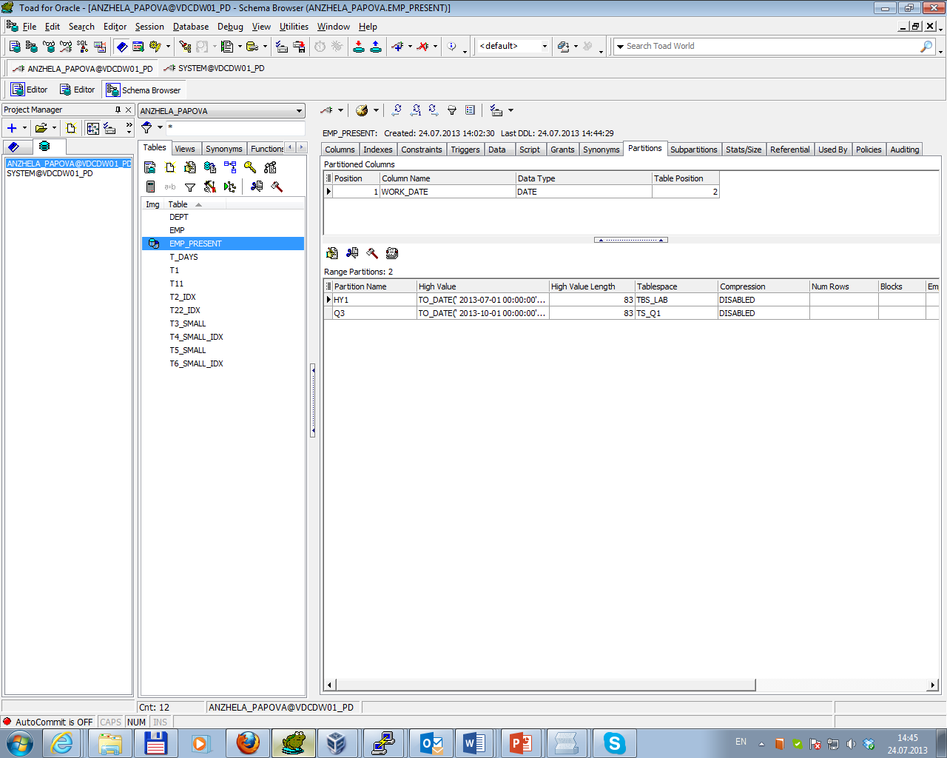

Splitting Partitions

Command ALTER TABLE ... SPLIT PARTITION allows to redistribute the contents of a partition into two new partitions. In this case it’s necessary to specify a value of the partitioning key column within the range of the partition at which to split the partition. The result of command running is presented below.

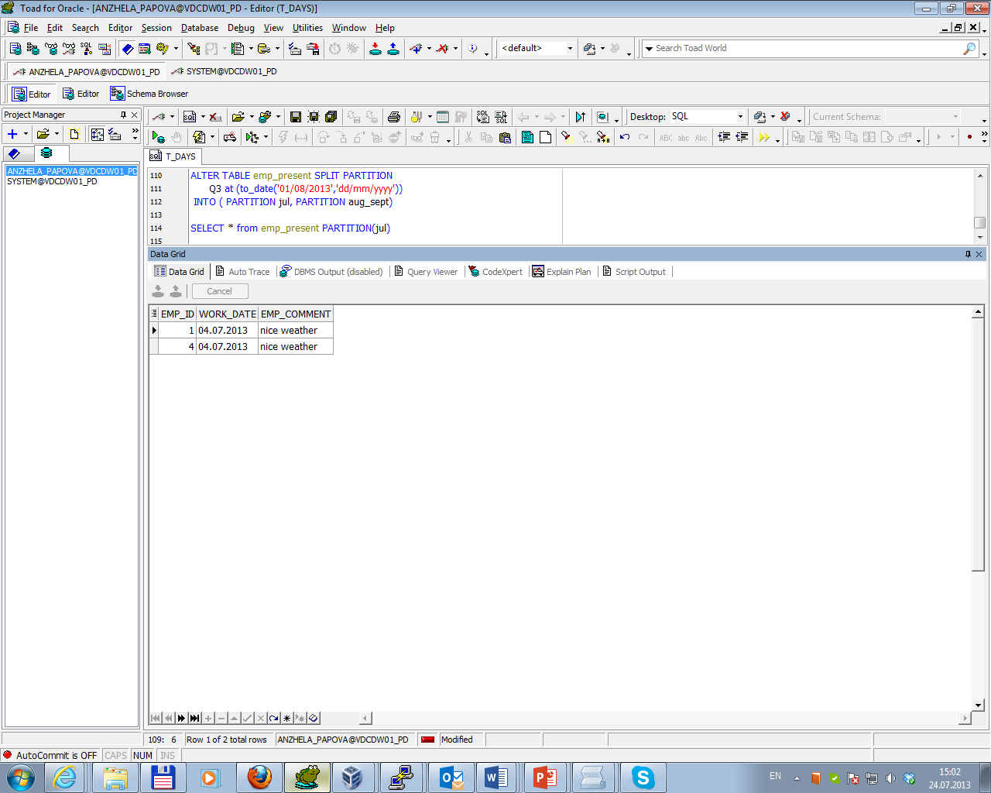

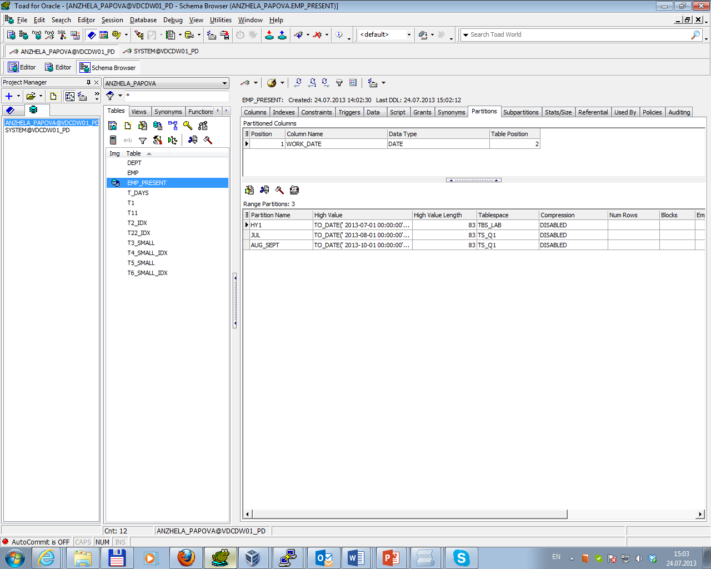

Truncating Partitions

Command ALTER TABLE ... TRUNCATE PARTITION allows to remove all rows from a table partition. Truncating a partition is similar to dropping a partition, except that the partition is emptied of its data, but not physically dropped. The result of command running is presented below.

